<https://www.entityframeworktutorial.net/code-first/code-based-migration-in-code-first.aspx>

Code-Based Migration in Entity Framework 6

In the previous chapter, you learned about automated migration which automatically updates the database schema when you change domain classes. Here, you will learn about code-based migration.

The code-based migration provides more control on the migration and allows you to configure additional things such as setting a default value of a column, configure a computed column etc.

In order to use code-based migration, you need to execute the following commands in the Package Manager Console in Visual Studio:

1. **Enable-Migrations:** Enables the migration in your project by creating a Configuration class.
2. **Add-Migration:** Creates a new migration class as per specified name with the Up() and Down() methods.
3. **Update-Database:** Executes the last migration file created by the Add-Migration command and applies changes to the database schema.

To use code-based migrations, first execute the enable-migrations command in the Package Manager Console. Open the Package Manager Console from Tools → Library Package Manager → Package Manager Console and then run the enable-migrations command (make sure that the default project is the project where your context class is).

[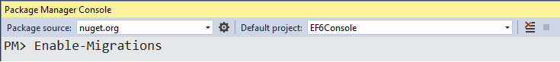](https://www.entityframeworktutorial.net/Images/codefirst/codebased2.PNG)

The Enable-Migrations command will create the Configuration class derived from DbMigrationsConfiguration with AutomaticMigrationsEnabled = false.

Now, you need to set the database initializer MigrateDatabaseToLatestVersion in your context class, as shown below.

public class SchoolContext: DbContext

{

public SchoolDBContext(): base("SchoolDB")

{

Database.SetInitializer(new MigrateDatabaseToLatestVersion<SchoolDBContext, EF6Console.Migrations.Configuration>());

}

public DbSet<Student> Students { get; set; }

protected override void OnModelCreating(DbModelBuilder modelBuilder)

{

}

}

Now, you have to create a migration class using the Add-Migration command with the name of your migration class, as shown below.

[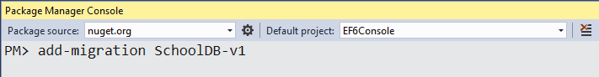](https://www.entityframeworktutorial.net/images/codefirst/codebased1.PNG)

The above command will create a <timestamp>_SchoolDB-v1.cs file with the Up() and Down() methods, as shown below.

[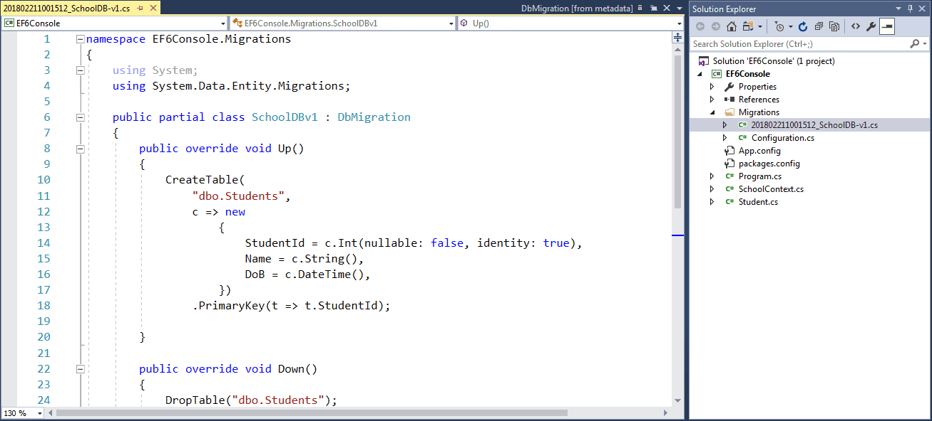](https://www.entityframeworktutorial.net/images/codefirst/codebased3.PNG)

As you can see, the Up() method contains code for creating database objects and the Down() method contains code for dropping or deleting database objects. You may also write your own custom code for additional configurations. This is the advantage over automated migration.

To know more about add-migration command parameters, execute get-help add-migration or get-help add-migration -detailed commands in PMC, as shown below.

PM> get-help add-migration

NAME

Add-Migration

SYNOPSIS

Scaffolds a migration script for any pending model changes.

SYNTAX

Add-Migration [-Name] <String> [-Force] [-ProjectName <String>] [-StartUpProjectName <String>]

[-ConfigurationTypeName <String>] [-ConnectionStringName <String>] [-IgnoreChanges]

[-AppDomainBaseDirectory <String>] [<CommonParameters>]

Add-Migration [-Name] <String> [-Force] [-ProjectName <String>] [-StartUpProjectName <String>]

[-ConfigurationTypeName <String>] -ConnectionString <String> -ConnectionProviderName <String>

[-IgnoreChanges] [-AppDomainBaseDirectory <String>] [<CommonParameters>]

DESCRIPTION

Scaffolds a new migration script and adds it to the project.

RELATED LINKS

REMARKS

To see the examples, type: "get-help Add-Migration -examples".

For more information, type: "get-help Add-Migration -detailed".

For technical information, type: "get-help Add-Migration -full".

After creating a migration file using the add-migration command, you have to update the database. Execute the Update-Database command to create or modify a database schema. Use the –verbose option to view the SQL statements being applied to the target database.

[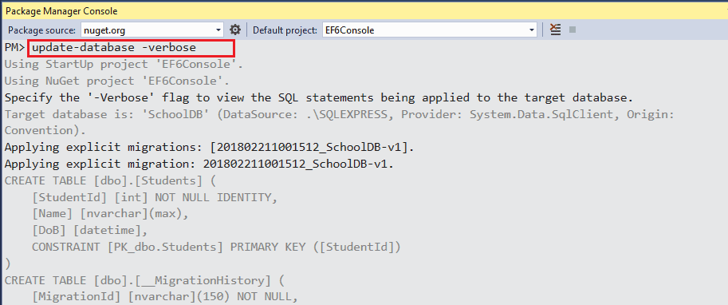](https://www.entityframeworktutorial.net/images/codefirst/codebased4.PNG)

Execute the get-help update-database or get-help update-database -detailed command in PMC to know more about the command.

PM> get-help update-database

NAME

Update-Database

SYNOPSIS

Applies any pending migrations to the database.

SYNTAX

Update-Database [-SourceMigration <String>] [-TargetMigration <String>] [-Script] [-Force]

[-ProjectName <String>] [-StartUpProjectName <String>] [-ConfigurationTypeName <String>]

[-ConnectionStringName <String>] [-AppDomainBaseDirectory <String>] [<CommonParameters>]

Update-Database [-SourceMigration <String>] [-TargetMigration <String>] [-Script] [-Force]

[-ProjectName <String>] [-StartUpProjectName <String>] [-ConfigurationTypeName <String>]

-ConnectionString <String> -ConnectionProviderName <String> [-AppDomainBaseDirectory <String>]

[<CommonParameters>]

DESCRIPTION

Updates the database to the current model by applying pending migrations.

RELATED LINKS

REMARKS

To see the examples, type: "get-help Update-Database -examples".

For more information, type: "get-help Update-Database -detailed".

For technical information, type: "get-help Update-Database -full".

At this point, the database will be created or updated. Now, whenever you change the domain classes, execute Add-Migration with the name parameter to create a new migration file and then execute the Update-Database command to apply the changes to the database schema.

Rollback Migration

Suppose you want to roll back the database schema to any of the previous states, then you can execute the update-database command with the –TargetMigration parameter to the point which you want to roll back to. For example, suppose there are many migrations applied to the above SchoolDB database but you want to roll back to the first migration. Then execute the following command.

PM> update-database -TargetMigration:SchoolDB-v1

[Download EF 6 Code-First Demo Project from Github](https://github.com/entityframeworktutorial/EF6-Code-First-Demo)

PM> Add-Migration -ConnectionString "Server=(LocalDB)\MyInstance;AttachDBFileName=D:\MieiProgetti\LegalSpeedUMax\LSDBManager\LSDBLocal.mdf;Integrated Security=true;" -StartUpProjectName "LSDBManager"

cmdlet Add-Migration at command pipeline position 1

Supply values for the following parameters:

Name: AddNewTableFatture

ConnectionProviderName: System.Data.SqlClient

Scaffolding migration 'AddNewTableFatture'.

The Designer Code for this migration file includes a snapshot of your current Code First model. This snapshot is used to calculate the changes to your model when you scaffold the next migration. If you make additional changes to your model that you want to include in this migration, then you can re-scaffold it by running 'Add-Migration AddNewTableFatture' again.

--------------------------------------------------------------------------------------------------

Imports System

Imports System.Data.Entity.Migrations

Imports Microsoft.VisualBasic

Namespace Migrations

Public Partial Class AddNewTableFatture

Inherits DbMigration

Public Overrides Sub Up()

CreateTable(

"dbo.Fatture",

Function(c) New With

{

.IdFattura = c.Int(nullable:=False, identity:=True),

.NumFattura = c.Int(nullable:=False),

.OggettoFattura = c.String(nullable:=False, maxLength:=250),

.DataFattura = c.DateTime(nullable:=False, precision:=7,

storeType:="datetime2"),

.DataInserimento = c.DateTime(precision:=7, storeType:="datetime2"),

.NomeCliente = c.String(maxLength:=100),

.ImportoTotaleFattura = c.Decimal(nullable:=True, precision:=6, scale:=2)

}) _

.PrimaryKey(Function(t) t.IdFattura)

End Sub

Public Overrides Sub Down()

DropTable("dbo.Fatture")

End Sub

End Class

End Namespace

--------------------------------------------------------------------------------------------------

PM> Update-Database -ConnectionString "Server=(LocalDB)\MyInstance;AttachDBFileName=D:\MieiProgetti\LegalSpeedUMax\LSDBManager\LSDBLocal.mdf;Integrated Security=true;" -StartUpProjectName "LSDBManager"

cmdlet Update-Database at command pipeline position 1

Supply values for the following parameters:

ConnectionProviderName: System.Data.SqlClient

Specify the '-Verbose' flag to view the SQL statements being applied to the target database.

Applying explicit migrations: [202204221832534_AddNewTableFatture].

Applying explicit migration: 202204221832534_AddNewTableFatture.

Running Seed method.